James Young

Homework 8

Exercise 2

**1. State the type of factorial design this is. Use base and exponents**

This is a 3x4 factorial design (31x41)

**2. State the number of levels for each factor**

There are 3 levels for “Factor A” and 4 levels for “Factor C”.

**3. State how many replications there are.**

There are 2 replicates of each combination of factor levels.

**4. State the number experimental combinations based on the design**

There are 12 total combinations based on the 3x4 design.

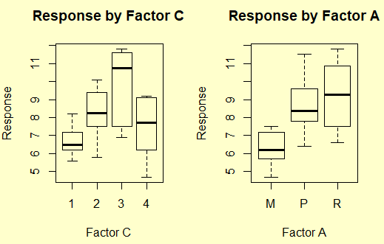**5. Provide a snip of side-by side box plots of each factor and comment initially on what you see**

Initial visual observation shows Factor C3 and

Factor AR seem to have the strongest positive

effect on the response variable when considered

independently of other dependent variables.

**6. Modify the code from class and find if any, 2nd order interactions**

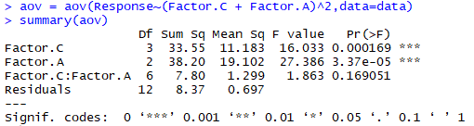I choose to use Factor C and Factor A but

exclude the interaction effect. This decision is

based on selecting only variables that have a

p-value < 0.05.

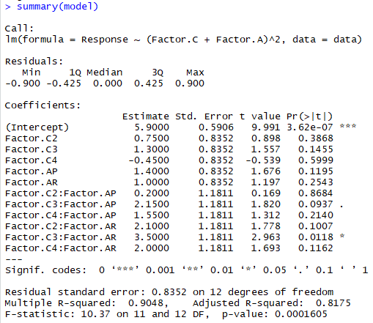**7. Fit a model using the lm() function and from the summary conduct an anova test selected. DO NOT USE THE COEFFICIENTS FITS, THIS IS AN ANOVA. Conduct a hypothesis test to test the mean difference of the factors you fit. State the hypothesis, use the R output and use the p-value only from the F test to perform the test, and provide the decision rule, and conclusion.**

$$H_{0}: μ_{i}= μ_{j} for all μ$$

$$H_{1}: μ_{i} ≠μ_{j} for at least 1 μ$$

When α = 0.05, F value = 10.37, therefore we reject $H_{0}$ and conclude

that at least one µ is different from another for Factor A and the

term of FactorA:FactorC.

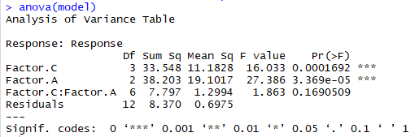**8. Step 7 tested for a global mean difference, use the anova function and provide a snip of the anova and**

Factor A and Factor C were significant dependent variables

based on p-value < 0.5 and the interaction term will be left out

of the model due to its overall lack of statistical significance.

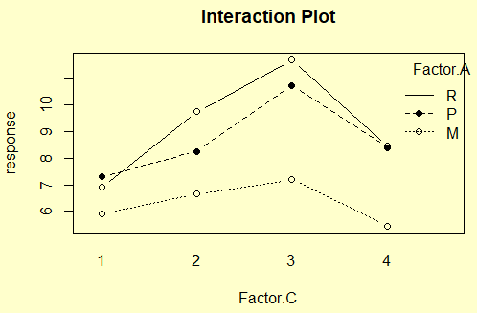**9. Construct an interaction plot using grain on the x-axis and Factor A as the plots in the window and answer the following,**

There is possible interaction between “R” and “P” Factor A between

“1” and “2” grain, and again between “3” and “4” grain.

These are not significant because the ANOVA test showed no interaction

effects with a p-value <0.05.

**10. Explain how much variation is explained by the factors you fit using the R squared.**

81.61% of variation is explained by

the mult. R-squared of 0.8161 and 76.5% of

variation is described by the adjusted

R-squared of 0.765. This is based off a model excluding interaction effects due to their lack of statistical significance.

**11. Provide a summary of your findings.**

I found that Factor A and Factor C were significant predictor variables based on ANOVA testing at α = 0.05. I also found that while some individual interactions are significant, the interaction variable as a whole is not significant.

**Exercise 11**

**1. State the type of factorial design this is. Use base and exponents**

The experimental factorial design is 32

**2. State the number of levels for each factor**

Each of the 2 factors have 3 levels.

**3. State how many replications there are.**

There were 6 replicates of each combination of factor levels.

**4. State the number experimental combinations based on the design**

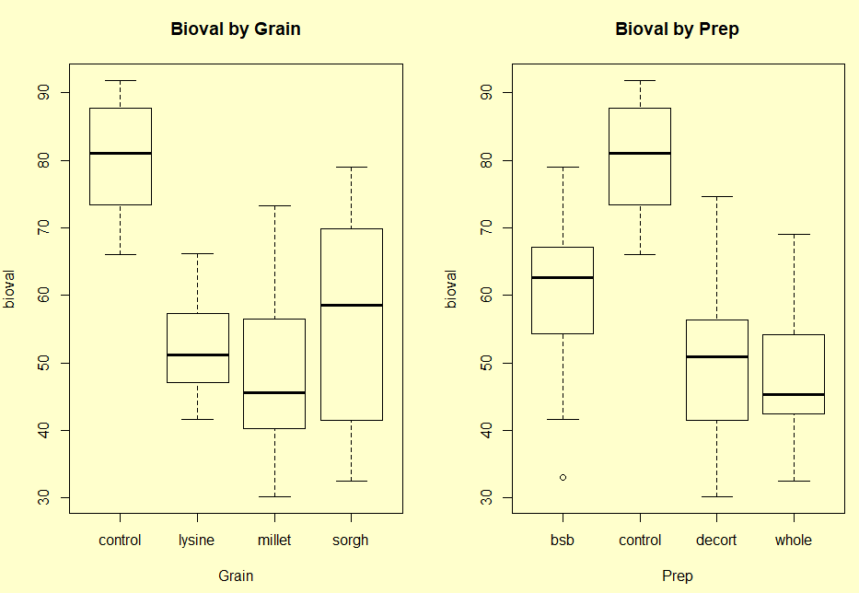There are 9 experimental combinations for this problem

and 1 control.

**5. Provide a snip of side-by side box plots of each factor**

**and comment initially on what you see**

I see that “sorgh” has the largest mean positive

effect on the response variable for the grain factor, and

“bsb” has the largest mean positive effect on the

response variable for the prep factor. Neither of these

factors had a level with a mean higher than the control.

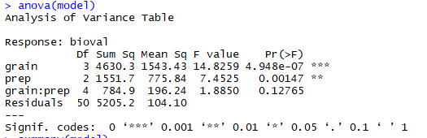**6. Modify the code from class and find if any, 2nd order interactions**

I choose to use grain and prep but

exclude the interaction effect. This decision is

based on selecting only variables that have a

p-value < 0.05.

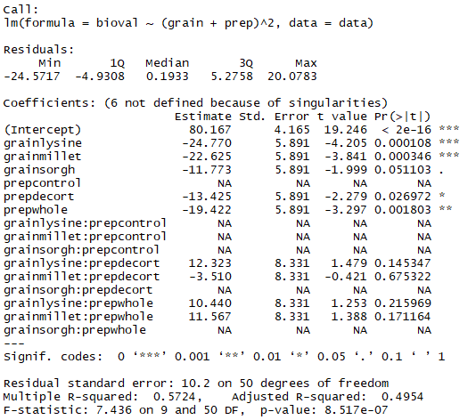**7. Fit a model using the lm() function and from the summary conduct an anova test selected. DO NOT USE THE COEFFICIENTS FITS, THIS IS AN ANOVA. Conduct a hypothesis test to test the mean difference of the factors you fit. State the hypothesis, use the R output and use the p-value only from the F test to perform the test, and provide the decision rule, and conclusion.**

$$H_{0}: μ_{i}= μ_{j} for all μ$$

$$H_{1}: μ_{i} ≠μ_{j} for at least 1 μ$$

When α = 0.05, F value = 10.37, therefore we reject $H_{0}$

and conclude that at least one µ is different from another

for “grain” and “prep” but not the interaction effects.

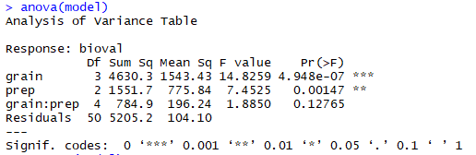**8. Step 7 tested for a global mean difference, use the anova function and provide a snip of the anova and**

Grain and prep were significant dependent variables

based on p-value < 0.5 and the interaction term will be left out

of the model due to its overall lack of statistical significance.

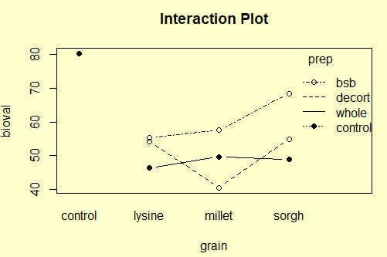**9. Construct an interaction plot using grain on the x-axis and Factor A as the plots in the window and answer the following**

There is possible interaction between “whole” and “decort” prep between

“lysine” and “millet” grain, and again between “millet” and “sorgh” grain.

These are not significant because the ANOVA test showed no interaction

effects with a p-value <0.05.

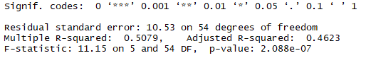**10. Explain how much variation is explained by the factors you fit using the R squared.**

50.79% of variation is explained by

the mult. R-squared of 0.5709 and 46.23% of

variation is described by the adjusted R-squared of 0.4623.

This is based of a model excluding interaction effects due to their lack of statistical significance.

**11. Provide a short summary of your findings.**

I found that “prep” and “grain” were significant predictor variables based on ANOVA testing at α = 0.05. I also found that there are not significant interaction effects.

**12. add step 12, use this code to reorder the treatment 10 (control) and run this code:**

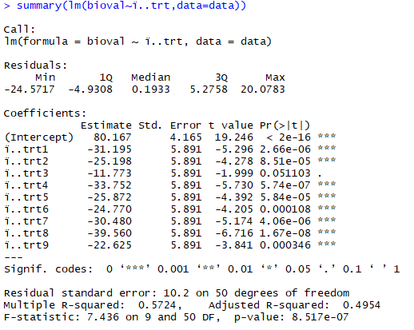All treatments are statistically

significantly different from the control mean except treatment 3.

Treatment 3 is “sorgh”, “gran” and

“bsb” preparation

**R- Code Appendix**

